EXPERIMENT - 4
AIM: Using the Employee schema, write queries with INNER JOIN, LEFT JOIN, selfjoin, 3-way join, correlated subqueries, EXISTS, and simulated INTERSECT and EXCEPT. Compare execution plans using EXPLAIN.

SOURCE CODE:
CREATE TABLE Department ( dept_id INT PRIMARY KEY, dept_name VARCHAR(50)
);
CREATE TABLE Project ( project_id INT PRIMARY KEY, project_name VARCHAR(50), dept_id INT,
FOREIGN KEY (dept_id) REFERENCES Department(dept_id)
);
CREATE TABLE Employee ( emp_id INT PRIMARY KEY, emp_name VARCHAR(50), dept_id INT,
project_id INT,
salary DECIMAL(10,2), city VARCHAR(50),
FOREIGN KEY (dept_id) REFERENCES Department(dept_id), FOREIGN KEY (project_id) REFERENCES Project(project_id)
);
INSERT INTO Department VALUES
(1, 'HR'), (2, 'Finance'), (3, 'IT'), (4, 'Marketing'), (5, 'Operations');
INSERT INTO Project VALUES
(101, 'Recruitment System', 1), (102, 'Payroll Automation', 2),
(103, 'Cybersecurity Upgrade', 3), (104, 'Website Revamp', 3),
(105, 'Ad Campaign', 4), (106, 'Market Research', 4),
(107, 'Logistics Optimization', 5), (108, 'Inventory System', 5);
INSERT INTO Employee VALUES (1, 'Alice', 1, 101, 45000, 'Delhi'),
(2, 'Bob', 1, 101, 42000, 'Mumbai'),
(3, 'Charlie', 1, 101, 47000, 'Pune'),
(4, 'David', 2, 102, 55000, 'Delhi'),
(5, 'Eva', 2, 102, 60000, 'Lucknow'),
(6, 'Frank', 2, 102, 52000, 'Chennai'),
(7, 'Grace', 3, 103, 70000, 'Bangalore'),
(8, 'Hannah', 3, 103, 68000, 'Hyderabad'),

(9, 'Ian', 3, 104, 72000, 'Delhi'),
(10, 'Jack', 3, 104, 65000, 'Pune'),

(11, 'Karen', 3, 104, 64000, 'Mumbai'),
(12, 'Leo', 4, 105, 48000, 'Delhi'),
(13, 'Mia', 4, 105, 50000, 'Lucknow'),
(14, 'Nina', 4, 106, 51000, 'Chennai'),
(15, 'Oscar', 4, 106, 53000, 'Delhi'),
(16, 'Paul', 5, 107, 56000, 'Hyderabad'),
(17, 'Quinn', 5, 107, 57000, 'Bangalore'),
(18, 'Rita', 5, 107, 59000, 'Delhi'),
(19, 'Sam', 5, 108, 60000, 'Lucknow'),
(20, 'Tina', 5, 108, 61000, 'Mumbai'),
(21, 'Uma', 5, 108, 62000, 'Chennai'),
(22, 'Victor', 2, 102, 53000, 'Delhi'),
(23, 'Wendy', 2, 102, 54000, 'Hyderabad'),
(24, 'Xavier', 3, 103, 71000, 'Bangalore'),
(25, 'Yara', 3, 104, 66000, 'Lucknow'),
(26, 'Zane', 4, 105, 49000, 'Delhi'),
(27, 'Aditi', 4, 106, 52000, 'Mumbai'),
(28, 'Bhavya', 1, 101, 46000, 'Chennai'),
(29, 'Chetan', 1, 101, 43000, 'Lucknow'),
(30, 'Devika', 5, 107, 58000, 'Delhi');
SELECT E.emp_id, E.emp_name, D.dept_name FROM Employee E
INNER JOIN Department D ON E.dept_id = D.dept_id;
SELECT D.dept_id, D.dept_name, E.emp_name FROM Department D
LEFT JOIN Employee E
ON D.dept_id = E.dept_id;
SELECT E1.emp_name AS Employee1, E2.emp_name AS Employee2, E1.dept_id FROM Employee E1
INNER JOIN Employee E2 ON E1.dept_id = E2.dept_id
AND E1.emp_id < E2.emp_id;
SELECT E.emp_name, P.project_name, D.dept_name FROM Employee E
INNER JOIN Project P
ON E.project_id = P.project_id INNER JOIN Department D
ON E.dept_id = D.dept_id;
SELECT E.emp_name, E.dept_id, E.salary FROM Employee E
WHERE E.salary > ( SELECT AVG(E2.salary)

FROM Employee E2
WHERE E2.dept_id = E.dept_id );

SELECT E.emp_id, E.emp_name, E.dept_id FROM Employee E
WHERE EXISTS ( SELECT 1
FROM Project P
WHERE P.dept_id = E.dept_id );
SELECT emp_name FROM Employee WHERE emp_id IN (
SELECT emp_id FROM Employee WHERE city = 'Delhi' )
AND emp_id IN ( SELECT emp_id FROM Employee
WHERE salary > 60000 );
SELECT emp_name FROM Employee
WHERE emp_id NOT IN ( SELECT emp_id FROM Employee WHERE city = 'Delhi' );
EXPLAIN
SELECT E.emp_name, D.dept_name FROM Employee E
INNER JOIN Department D ON E.dept_id = D.dept_id;
EXPLAIN
SELECT D.dept_name, E.emp_name FROM Department D
LEFT JOIN Employee E
ON D.dept_id = E.dept_id;
EXPLAIN
SELECT E.emp_name, E.salary FROM Employee E
WHERE E.salary > ( SELECT AVG(E2.salary) FROM Employee E2
WHERE E2.dept_id = E.dept_id );
EXPLAIN
SELECT E.emp_name FROM Employee E WHERE EXISTS (
SELECT 1

FROM Project P
WHERE P.dept_id = E.dept_id );

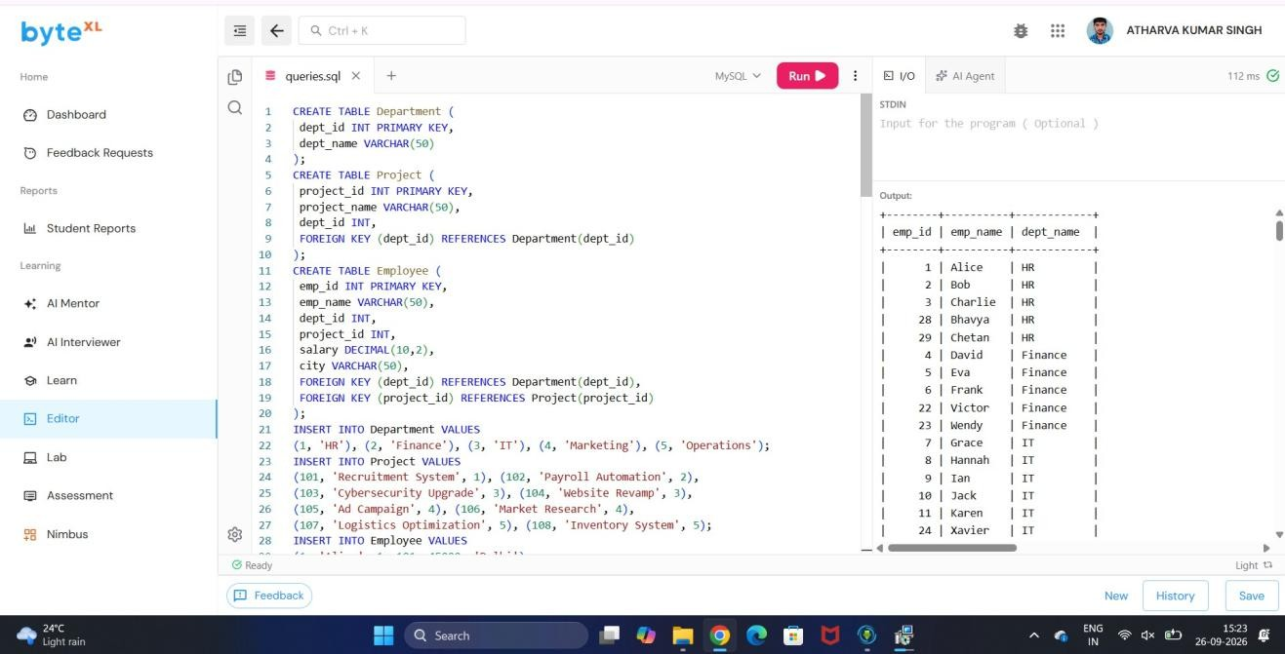

OUTPUT :-

